

E- Project Report

**Online Health Insurance Mgmt**

**(Batch: NK_2202F1)**

*Project Instructor*

**Sir Muneeb Ullah Khan**

Submitted by:

**UMER FAROOQ Student1364249**

**MUBASHIR REHMAN SIDDIQUI Student1362758**

**MUHAMMAD UZAIR Student1366647**

**TAHA TANVEER Student1336084**

1

**Declaration**

*I hear by declare that the following documented project report titled “Online Health Insurance Management” is an authentic work done by us.*

*The project was undertaken as a park of the course curriculum of E-Project, Aptech NK. This has not been submitted to any other examination body earlier.*

2

*CERTIFICATE*

**This is to certify that**

**UMER FAROOQ Student1364249**

**MUBASHIR REHMAN SIDDIQUI Student1362758**

**MUHAMMAD UZAIR Student1366647**

**TAHA TANVEER Student1336084**

Has Successfully Designed & Developed:

*Online Health Insurance*

*Umer Farooq*

*Mubashir Rehman Siddiqui*

*Muhammad Uzair*

*Taha Tanveer*

Date of issue:

**15-7-2023**

**3**

**Preface**

In this report firstly we explained the description of our project, in this a user simply go to the website and easily can view his desired products and its description, whatever he/she wants to find about health insurance Management etc. information on our website.

The overall experience of this project was wonderful for the team. The members got to learn many things and have developed their problem-solving skills. The features that were promised in the beginning of the project were achieved and fulfilled and got each and every goal of this project.

External of this project is satisfied from the team and his work and that is project team achievement. It is hope that this website will fulfill the purpose it is designed for.

4

Acknowledgment

First of all, we thank Almighty Allah who gives us the strength and ability to think, work and deliver what we are assigned to do.

We earnestly hope that this project will provide all the necessarily information required for the user to fulfill their inspiration. However, suggestions for improvement of the project will be thankful received & acknowledge.

5

**SYNOPSIS**

**Online Health Insurance Management**

From the time when **Online Health Insurance Management In 1983, a group of visionary minds saw the untapped potential in merging healthcare with emerging computer technologies. With a shared passion for simplifying health insurance, they founded "Online Health Insurance Management." This company embarked on a transformative journey, forever altering the way people engaged with their insurance and healthcare.**

6

**Contents**

**Chapter Introduction 09**

* Goals and objectives 09
* System Statement of scope 09
* Theoretical background 09
* 10

**Chapter Problem Statement 11**

2.1 Requirement Specification 11

2.2 Hardware / Software Requirements 12

**Chapter System Estimates & Actual Outcome 13**

* Estimation Techniques applied 13
* System Estimate & actual outcome 14
* Estimation of Time for the Project 14
* Actual Time for the Project 14
* Actual Results 15
* System resources 15
* System Resources Used 15
* **Chapter Conclusion 16**

Conclusion\summary 16

4.2 List of Validation 16

**J. APPENDICES**

* Project Schedule
* Snap Shots of Project

**K. REFERENCES**

**CHAPTER 01**

**INTRODUCTION**

* **Introduction**

***At Online Health Insurance Management, we're rewriting the rules of healthcare management, putting you at the center of your health insurance experience. Our state-of-the-art online platform is designed to transform the way you interact with your insurance, providing you with a seamless and intuitive way to manage your health and well-being.***

***In a world where technology is changing the way we live and work, it's time for healthcare to catch up. Founded in 1983, Online Health Insurance Management has been a pioneer in revolutionizing the way health insurance is accessed, understood, and managed. Our platform is the result of decades of dedication to simplifying the complexities of insurance and bringing you the tools you need to make informed decisions about your health.***

**Goals and objectives**

Simplifying Healthcare Management

**Objective:** Develop an intuitive and user-friendly online platform that allows users to easily access, manage, and understand their health insurance information, including coverage details, claims history, and payment options. **System statement of scope**

The scope of the Online Health Insurance Management system encompasses the various functionalities and features that the platform offers to users, ensuring a comprehensive and user-friendly experience for managing their health insurance.

**Theoretical Background**

We choose windows 10 because there is the biggest market share of windows 10 nowadays and is increasing day by day as various platforms are working for it.

* **Technology & Tools/hardware components**

**1.4.1 Asp.Net**

In 2002, Microsoft released Asp.NET Framework, a development platform for creating Windows apps. Today ASP.NET Framework is at version 4.8 and remains fully supported by Microsoft. In 2014, Microsoft introduced .NET Core as a cross-platform, open-source successor to Asp.NET Framework.

**SQL server is** **a database management system**.  
  
It may be anything from a simple shopping list to a picture gallery or the vast amounts of information in a corporate network. To add, access, and process data stored in a computer database, you need a database management system such as SQL Server.

**1.4.3**

**CHAPTER 02**

**PROBLEM STATEMENT**

* **Problem Statement**

In the current healthcare landscape, the management of health insurance remains complex, time-consuming, and often confusing for individuals, employers, and healthcare providers. Traditional methods of handling insurance paperwork, claims processing, and accessing coverage information have proven to be inefficient and prone to errors. Moreover, the lack of user-friendly tools and resources hinders informed decision-making and engagement in preventive healthcare practices. As a result, there is a pressing need for a comprehensive and streamlined solution that addresses these challenges. In the current healthcare landscape, the management of health insurance remains complex, time-consuming, and often confusing for individuals, employers, and healthcare providers. Traditional methods of handling insurance paperwork, claims processing, and accessing coverage information have proven to be inefficient and prone to errors. Moreover, the lack of user-friendly tools and resources hinders informed decision-making and engagement in preventive healthcare practices. As a result, there is a pressing need for a comprehensive and streamlined solution that addresses these challenges. In the current healthcare landscape, the management of health insurance remains complex, time-consuming, and often confusing for individuals, employers, and healthcare providers. Traditional methods of handling insurance paperwork, claims processing, and accessing coverage information have proven to be inefficient and prone to errors. Moreover, the lack of user-friendly tools and resources hinders informed decision-making and engagement in preventive healthcare practices. As a result, there is a pressing need for a comprehensive and streamlined solution that addresses these challenges. In the current healthcare landscape, the management of health insurance remains complex, time-consuming, and often confusing for individuals, employers, and healthcare providers. Traditional methods of handling insurance paperwork, claims processing, and accessing coverage information have proven to be inefficient and prone to errors. Moreover, the lack of user-friendly tools and resources hinders informed decision-making and engagement in preventive healthcare practices. As a result, there is a pressing need for a comprehensive and streamlined solution that addresses these challenges. In the current healthcare landscape, the management of health insurance remains complex, time-consuming, and often confusing for individuals, employers, and healthcare providers. Traditional methods of handling insurance paperwork, claims processing, and accessing coverage information have proven to be inefficient and prone to errors. Moreover, the lack of user-friendly tools and resources hinders informed decision-making and engagement in preventive healthcare practices. As a result, there is a pressing need for a comprehensive and streamlined solution that addresses these challenges. In the current healthcare landscape, the management of health insurance remains complex, time-consuming, and often confusing for individuals, employers, and healthcare providers. Traditional methods of handling insurance paperwork, claims processing, and accessing coverage information have proven to be inefficient and prone to errors. Moreover, the lack of user-friendly tools and resources hinders informed decision-making and engagement in preventive healthcare practices. As a result, there is a pressing need for a comprehensive and streamlined solution that addresses these challenges. In the current healthcare landscape, the management of health insurance remains complex, time-consuming, and often confusing for individuals, employers, and healthcare providers. Traditional methods of handling insurance paperwork, claims processing, and accessing coverage information have proven to be inefficient and prone to errors. Moreover, the lack of user-friendly tools and resources hinders informed decision-making and engagement in preventive healthcare practices. As a result, there is a pressing need for a comprehensive and streamlined solution that addresses these challenges. In the current healthcare landscape, the management of health insurance remains complex, time-consuming, and often confusing for individuals, employers, and healthcare providers. Traditional methods of handling insurance paperwork, claims processing, and accessing coverage information have proven to be inefficient and prone to errors. Moreover, the lack of user-friendly tools and resources hinders informed decision-making and engagement in preventive healthcare practices. As a result, there is a pressing need for a comprehensive and streamlined solution that addresses these challenges. In the current healthcare landscape, the management of health insurance remains complex, time-consuming, and often confusing for individuals, employers, and healthcare providers. Traditional methods of handling insurance paperwork, claims processing, and accessing coverage information have proven to be inefficient and prone to errors. Moreover, the lack of user-friendly tools and resources hinders informed decision-making and engagement in preventive healthcare practices. As a result, there is a pressing need for a comprehensive and streamlined solution that addresses these challenges. In the current healthcare landscape, the management of health insurance remains complex, time-consuming, and often confusing for individuals, employers, and healthcare providers. Traditional methods of handling insurance paperwork, claims processing, and accessing coverage information have proven to be inefficient and prone to errors. Moreover, the lack of user-friendly tools and resources hinders informed decision-making and engagement in preventive healthcare practices. As a result, there is a pressing need for a comprehensive and streamlined solution that addresses these challenges. In the current healthcare landscape, the management of health insurance remains complex, time-consuming, and often confusing for individuals, employers, and healthcare providers. Traditional methods of handling insurance paperwork, claims processing, and accessing coverage information have proven to be inefficient and prone to errors. Moreover, the lack of user-friendly tools and resources hinders informed decision-making and engagement in preventive healthcare practices. As a result, there is a pressing need for a comprehensive and streamlined solution that addresses these challenges. In the current healthcare landscape, the management of health insurance remains complex, time-consuming, and often confusing for individuals, employers, and healthcare providers. Traditional methods of handling insurance paperwork, claims processing, and accessing coverage information have proven to be inefficient and prone to errors. Moreover, the lack of user-friendly tools and resources hinders informed decision-making and engagement in preventive healthcare practices. As a result, there is a pressing need for a comprehensive and streamlined solution that addresses these challenges. In the current healthcare landscape, the management of health insurance remains complex, time-consuming, and often confusing for individuals, employers, and healthcare providers. Traditional methods of handling insurance paperwork, claims processing, and accessing coverage information have proven to be inefficient and prone to errors. Moreover, the lack of user-friendly tools and resources hinders informed decision-making and engagement in preventive healthcare practices. As a result, there is a pressing need for a comprehensive and streamlined solution that addresses these challenges. In the current healthcare landscape, the management of health insurance remains complex, time-consuming, and often confusing for individuals, employers, and healthcare providers. Traditional methods of handling insurance paperwork, claims processing, and accessing coverage information have proven to be inefficient and prone to errors. Moreover, the lack of user-friendly tools and resources hinders informed decision-making and engagement in preventive healthcare practices. As a result, there is a pressing need for a comprehensive and streamlined solution that addresses these challenges. In the current healthcare landscape, the management of health insurance remains complex, time-consuming, and often confusing for individuals, employers, and healthcare providers. Traditional methods of handling insurance paperwork, claims processing, and accessing coverage information have proven to be inefficient and prone to errors. Moreover, the lack of user-friendly tools and resources hinders informed decision-making and engagement in preventive healthcare practices. As a result, there is a pressing need for a comprehensive and streamlined solution that addresses these challenges. In the current healthcare landscape, the management of health insurance remains complex, time-consuming, and often confusing for individuals, employers, and healthcare providers. Traditional methods of handling insurance paperwork, claims processing, and accessing coverage information have proven to be inefficient and prone to errors. Moreover, the lack of user-friendly tools and resources hinders informed decision-making and engagement in preventive healthcare practices. As a result, there is a pressing need for a comprehensive and streamlined solution that addresses these challenges. In the current healthcare landscape, the management of health insurance remains complex, time-consuming, and often confusing for individuals, employers, and healthcare providers. Traditional methods of handling insurance paperwork, claims processing, and accessing coverage information have proven to be inefficient and prone to errors. Moreover, the lack of user-friendly tools and resources hinders informed decision-making and engagement in preventive healthcare practices. As a result, there is a pressing need for a comprehensive and streamlined solution that addresses these challenges.

**Requirement Specification:**

The Web site is to be created based on the following requirements.

**Hardware/ Software Requirements**

**Hardware**

* A minimum computer system that will help you access all the tools in the courses is a Pentium 166 or better.
* 128 Megabytes of RAM or better

**Software**

* Microsoft SQL Server
* Visual Studio 2022
* ASP . Net
* Window 10

**CHAPTER 03**

**SYSTEM ESTIMATES & ACTUAL OUTCOME**

* **System Estimates and Actual Outcome**

Sometimes the software estimation becomes a huge below by mean of system decomposition and system resizing. System estimation and actual outcome shows your scope efforts, engineering efforts and deploy effort.

To estimate time and resources for project is a challenging task. At the initial it was such a difficult task to estimate its resources and time.

Based on the project scope, the estimation of time is discussed below

* **Estimation techniques applied and results.**

There are many estimation techniques for project estimation, but we considered very common and effective cost estimation by mean of exact time management. We considered the scope of estimation technique because project resources and uses may tolerate by mean of requirement**.**

* **System Estimates and Actual Outcome**
* **Estimation of time for the software**

|  |  |
| --- | --- |
| **Estimation Of time** | **Days** |
| Researching and information collecting period | 2 days |
| Analyzing other software and tools | 1 day |
| Formation of website | 27 days |
| Duration of Report | 25 days (simultaneously with project) |
| **Total time** | 30 days |

* **Actual time for the software**

|  |  |
| --- | --- |
| **Actual time** | **Days** |
| Researching and information collecting period | 1 and 1/2 days |
| Analyzing other software and tools | 1/2 day |
| Formation of website | 28 days |
| Duration of Report | 23 days (simultaneously with project) |
| **Total time** | 30 days |

* **Actual Results and Deviation from Estimates**

Actual time estimation is varied because project member was 3.

* **System Resources**

System is divided into two major parts, on the bases of which cost estimations were performed.

* Software
* Hardware

**System Resources Used**

* Microsoft SQL Server
* Visual Studio 2022
* ASP . Net

**CONCLUSION**

* **Conclusion / Summary**

The overall experience of this project was wonder full for the team. The members got to learn many things in fact faced many problems but, in the end, fixed them out. The features that were promised in the beginning of the project were achieved and got each goal of this project.

External of this project is satisfied from our teamwork and that is project`s team achievement. It is hoped that this application will fulfill the purpose, it is designed for.

**List of Validation**

|  |  |
| --- | --- |
| Option | Validation |
| Suitable logo on main page | Yes |
| Proper menu | Yes |
| All services details provided | Yes |
| Various pages have details about events | Yes |
| Contact us page | Yes |
| Events are properly categorized | Yes |

**Snap Shots of website:**

**“Section 1: Admin & Customer Home Page”**

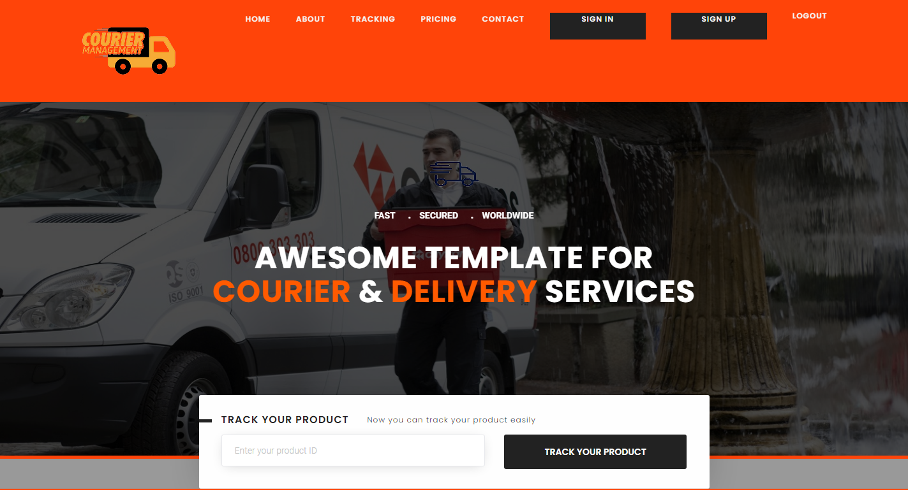

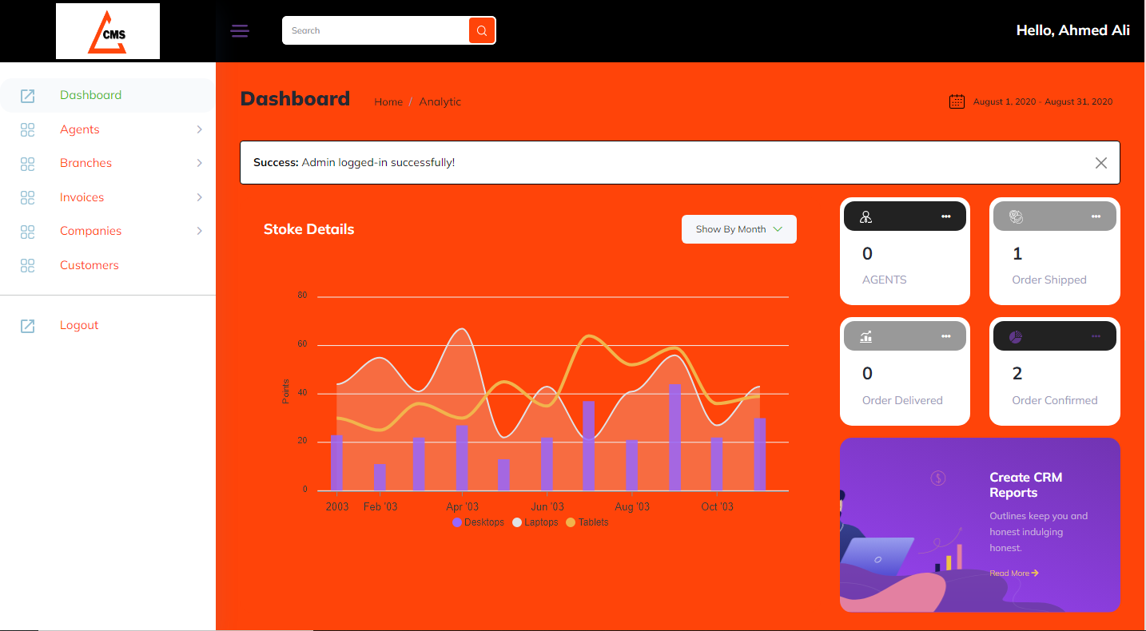

**“Section 2: About”**

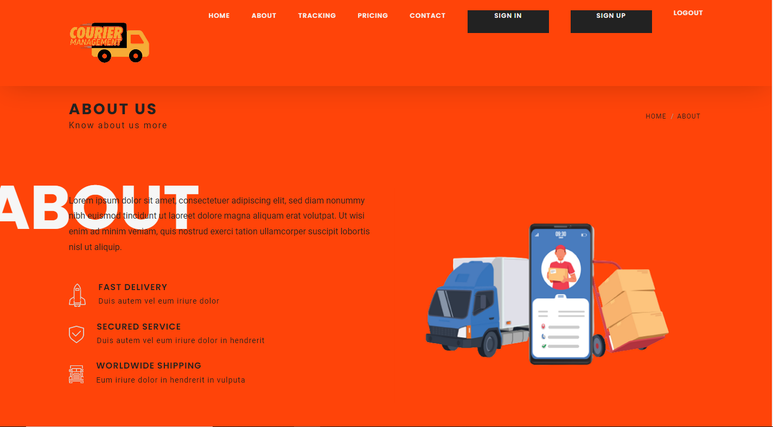

**Section 3: Pricing & Plans”**

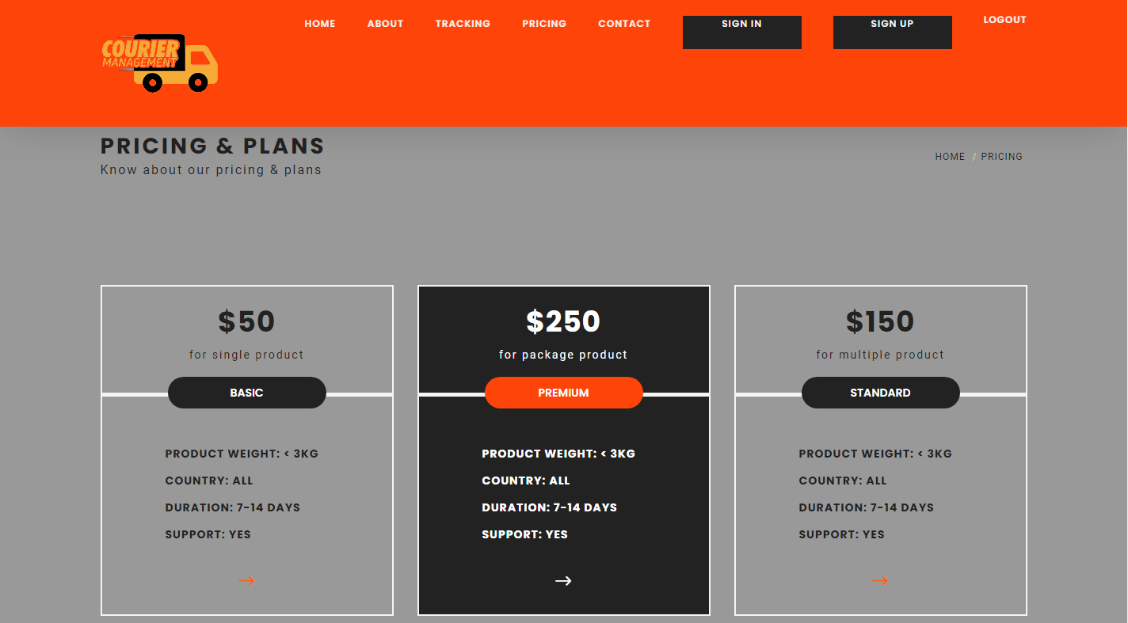

**“Section 5: “Sign in/up”**

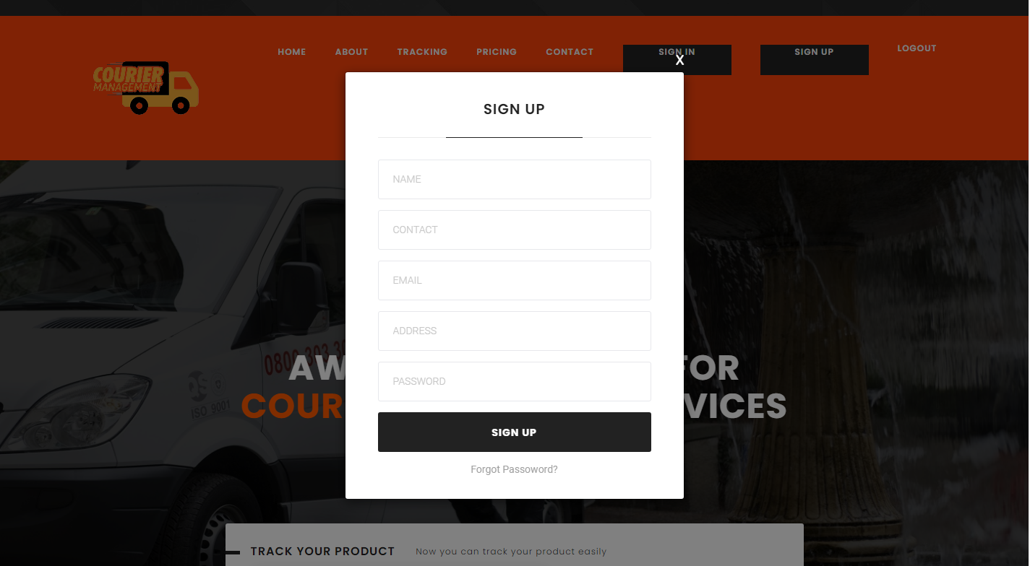



**“Section 5: “Contact Us”**

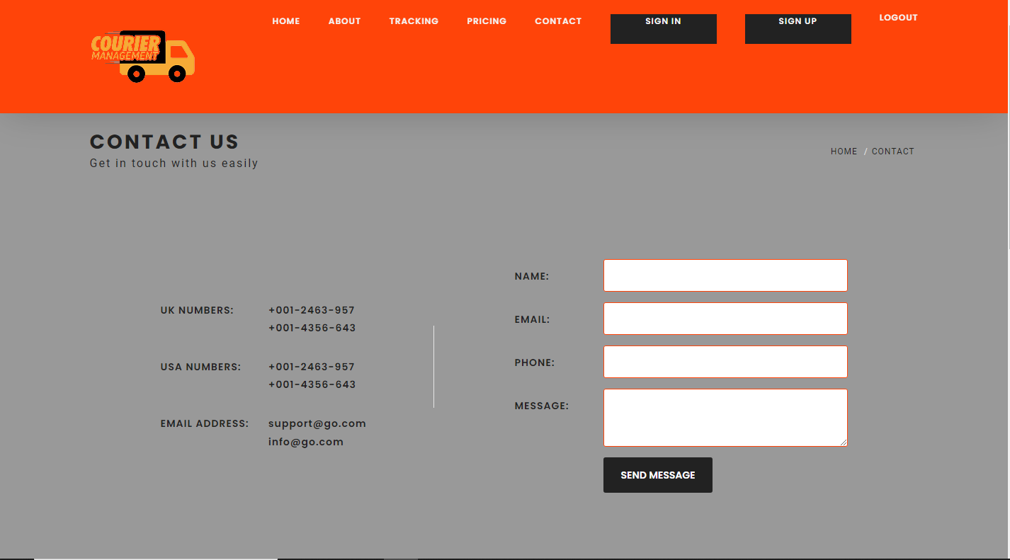

**“*End*”**